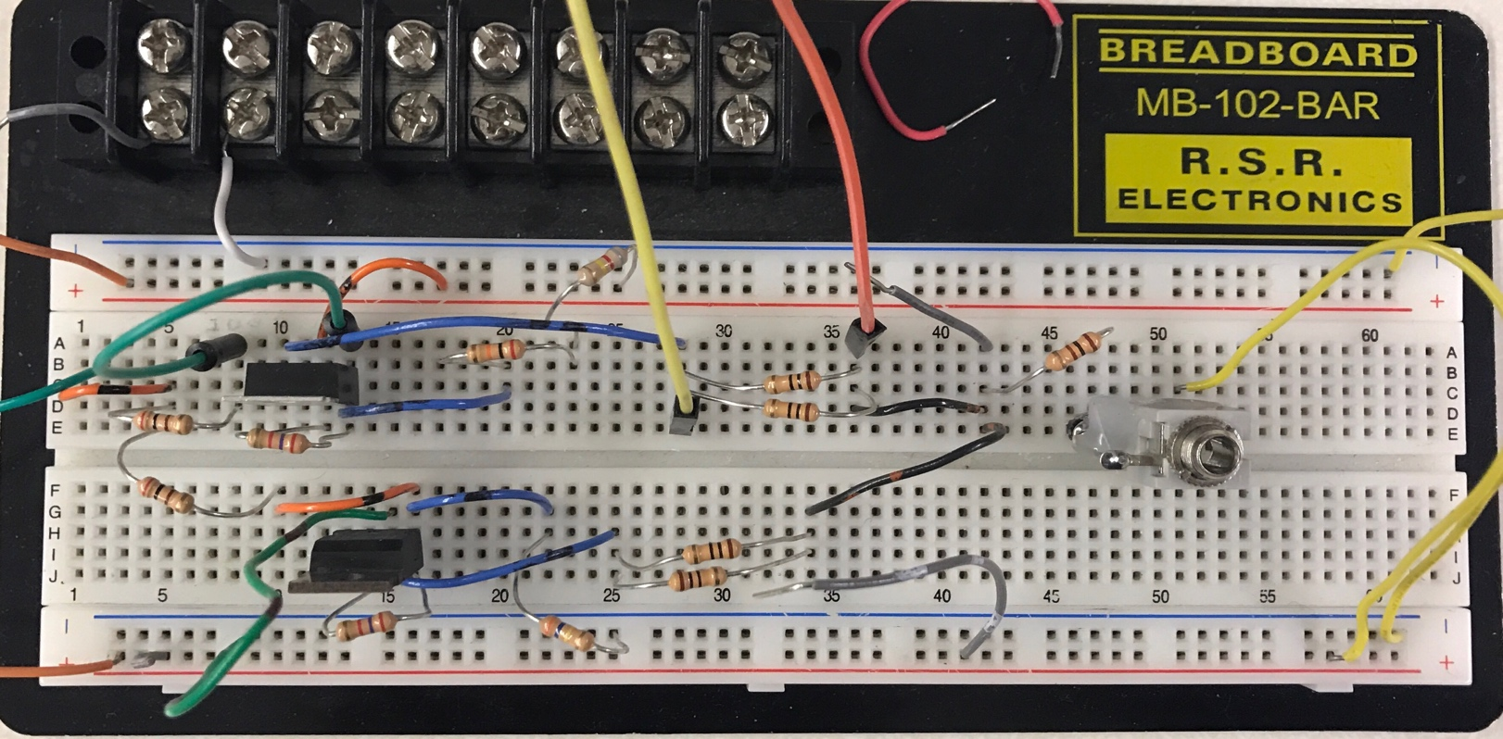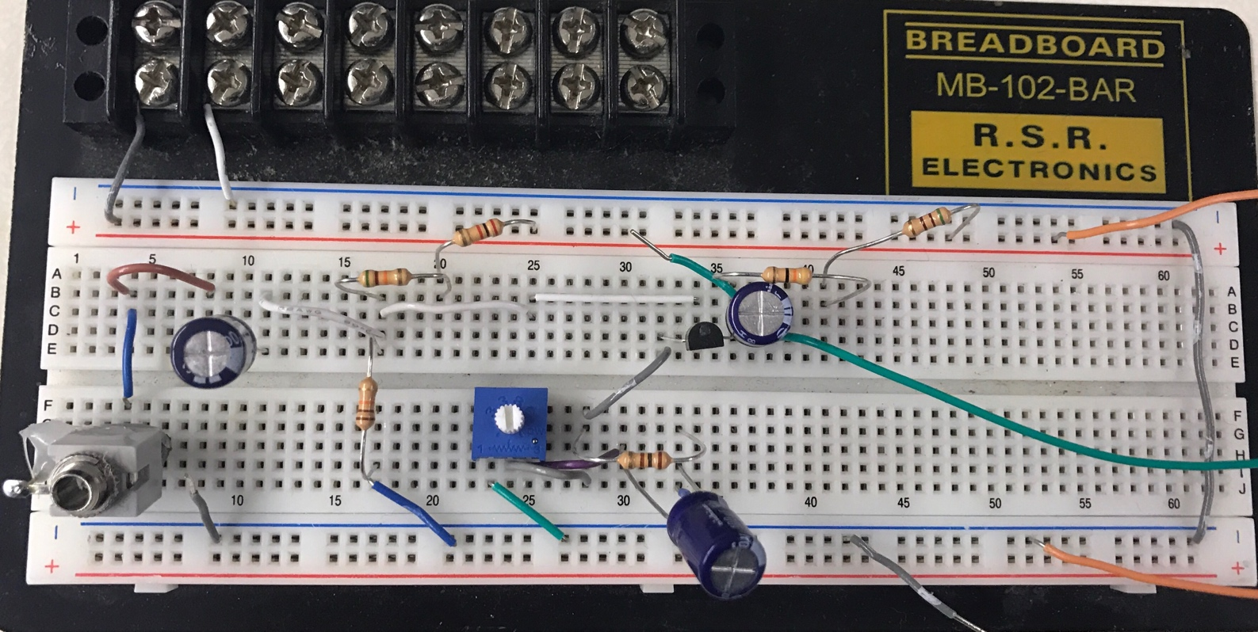

**Output Signal**

**PNP Loop**

**NPN Loop**

**Input Signal**

**Bias Resistors**

**Output to 2nd Stage**

**NPN Transistor**